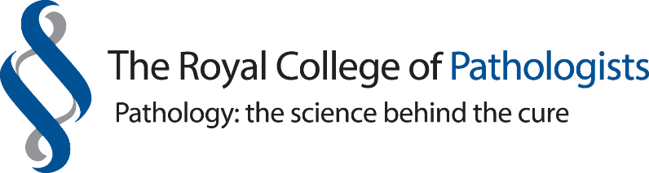

SIDS and SUDC: Past, Present and Future
17 & 18^{h} November 2021

To be held virtually
CPD Credits: 11
The aim of this event is to train the attendees on the epidemiology, risk factors and causes behind SIDS/SUDC, on the practicalities of the national protocol of SUDI and SUDC multiagency investigation and on the differential diagnosis of these conditions.

The objective is to present an up-date on the current protocol of investigation, research and understanding of the physio pathological mechanisms involved in cases of SUDI/SIDS.

This event is aimed at Paediatric and forensic pathologists, histopathology trainees, paediatricians
Day 1 - Wednesday, 17 November 2021
09.25 Registration
09.30 Welcome & Course contents, Professor Marta Cohen
09.40 Past, Present and Future, Professor Peter Fleming
10.20 Epidemiology of SIDS, Professor Peter Blair, Bristol
11.00 Break
11.20 Risk factors for SIDS, Dr Anna Pease, Bristol
12.00 The coroner’s perspective, Mr Ian Arrow, Plymouth
12.40 Lunch break
13.25 Natural causes of death different from SIDS, Professor Marta Cohen, Sheffield
14.05 The PM in SIDS & SUDC, Dr Tamas Marton, Birmingham
14.45 Break
15.05 Physiological mechanisms of SIDS part I, Professor Jan Marino Ramirez & team, Seattle
15.45 Traumatic deaths Vs natural causes of SUDI part I, Dr Michael Pollanen, Canada
16.25 Q&A
16.45 Close

Day 2 Thursday, 18 November 2021
11.25 Registration & Welcome
11:30 Metabolic causes of SUDI, Dr Simon Olpin, Sheffield
12.10 Home visit and Multiagency meeting, Dr Joanna Garstang, Birmingham
12.50 Arrhythmias in SIDS and SUDC, Professor Elijah Behr, St Georges, London
13.30 Lunch break
14:00 Non-Invasive post-mortem investigation in SUDI, Dr Ciaran Hutchinson GOSH and Dr Susan Shelmerdine GOSH
14:40 Traumatic deaths Vs natural causes of SUDI part II, Dr Michael Pollanen, Canada CH
15:20 Physiological mechanisms of SIDS part II, Professor Jan Marino Ramirez & team, Seattle
16.00 The National SUDIC registry, Professor Fleming, Bristol
16.30 Q&A
16.40 Close

